French II

Course Overview

Brian Andreychek

bdandreychek@ccps.org

Room: G117

**Goal:** Students in French II will extend their knowledge and vocabulary base while learning to speak in various tenses.

**Course Description:** Students will learn the following vocabulary concepts:

1. Shopping
2. House and home
3. Getting around Paris
4. Health and medicine

**Required Materials:** Students are not required to bring any additional materials beyond typical classroom supplies, such as:

Notebook/folder

Pencil

Notebook paper

Exception: Students will be required to maintain a Duolingo account online.

**Course Outline:**

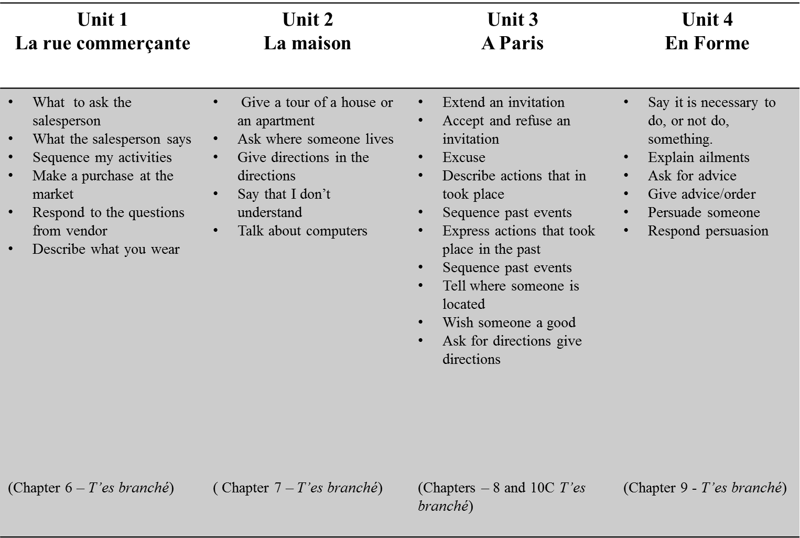

**Grading Criteria**

|  |  |  |
| --- | --- | --- |
| **Type of Assessment** | **Formative Assessments** | **Summative Assessments** |
| **Weight on Final Grade** | 40% | 60% |
| **Minimum per marking period** | 6 | 3 |
| **Qualities of Assessment** | * Provides teacher with snapshots of student understanding * Provides teacher with data to help guide future instruction * Provides students with feedback on next steps and understanding of content * Short, quick turnaround | * Comprehensive assessments * Documents mastery of content * May include multiple concepts and/or skills * Graded within 10 days of completion |
| **Retake** | Yes, within 10 days of return | Yes, within 10 days of return |
| **Examples (may include but are not limited to)** | Worksheets, notebook checks, teacher-made quizzes, short written assignments, homework, labs | Tests, quizzes, essays, projects, formal lab reports |

The following chart depicts the scales used to calculate end-of-marking period and end-of-course grades.  Percentages earned for marking period grades as well as quality points will reflect actual scores and will not be "rounded up."

|  |  |  |  |
| --- | --- | --- | --- |
| Percentage | Letter Grade | Quality Point | Final Grade Range |
| 93-100% | A | 4.00 | 3.75-4.00 |
| 90-92.9% | A- | 3.67 | 3.48-3.74 |
| 87-89.9% | B+ | 3.33 | 3.20-3.47 |
| 83-86.9% | B | 3.00 | 2.80-3.19 |
| 80-82.9% | B- | 2.67 | 2.50-2.79 |
| 77-79.9% | C+ | 2.33 | 2.20-2.49 |
| 73-76.9% | C | 2.00 | 1.80-2.19 |
| 70-72.9% | C- | 1.67 | 1.50-1.79 |
| 67-69.9% | D+ | 1.33 | 1.20-1.49 |
| 60-66.9% | D | 1.00 | 0.70-1.19 |
| 0-59.9% | F | 0 | 0-0.69 |

Final Grades will be calculated by averaging quality points earned from each marking period.

Extra credit and homework will not be used to improve students’ grades.

In calculating GPA, honors courses will be weighted by adding 1.0 of each honors level course and 1.5 for each Advanced Placement course (contingent upon students taking the Advanced Placement exam).

**Attendance and Make-up Policy:** Students who are absent from class when an assignment is given may make-up the work regardless of reason for absence. A minimum of two class days will be allowed for each day of absence. If the assignment is turned in beyond the allotted number of days, students will forfeit a letter grade for each day.

**Late Work Policy:** Students may turn in late work regardless of the reason.  A minimum of **two class days** will be allowed for a late assignment with an academic penalty of not greater than five percent per late day of the assignment's total grade. If the assignment is turned in beyond the allotted number of days, students will forfeit a letter grade for each day.

**Assessment Re-take Policy:** Students may complete retakes on all assessments (formative and summative) that earn less than an 85%.

* Assessments may be retaken during the school day or at a mutually agreeable time.
* The retake may be same assessment, a comparable assessment, and/or assessment corrections {as outlined by the instructional coordinator.}
* If a student retakes an assessment, the highest grade he/she can earn is an 85%.
* Students will retake the assessment within ten (10) school days after the initial assessment has been graded and returned.

**Teacher Contact Information**: The teacher is always open to questions and can be contacted in the following ways:

* In the morning: during homeroom
* In class: during drill time and revisit
* After hours: by email at bdandreychek@ccps.org

**Behavior Expectations:** Students are expected to behave in a manner appropriate for an academic institution that assists and contributes to the learning environment and encourages the acquisition of knowledge for themselves and others.